**Project Design Phase-II**

**Data Flow Diagram & User Stories**

|  |  |
| --- | --- |
| Date | 30 June 2025 |
| Team ID | LTVIP2025TMID30156 |
| Project Name | Educational Organisation Using ServiceNow |
| Maximum Marks | 4 Marks |

**Data Flow Diagrams:**

A **Data Flow Diagram (DFD)** offers a visual blueprint of how information travels through the *Educational Institution’s ServiceNow system*. It helps stakeholders grasp how students interact with the service portal, how their requests are categorized, processed, and resolved.

In this project, a well-structured DFD clearly illustrates:

* How students, faculty, and support agents initiate service requests through a centralized **ServiceNow portal**
* How data is automatically categorized, validated, and routed to specific **assignment groups** like academic help desks or IT teams
* How information is updated in real time within dashboards and **knowledge bases**, ensuring transparency
* Where system logs, request status updates, and student records are securely stored for administrative access

This diagram not only represents the **empathize and design phases** but also sets a strong foundation for planning automation, escalation paths, and real-time analytics in an educational environment.

.

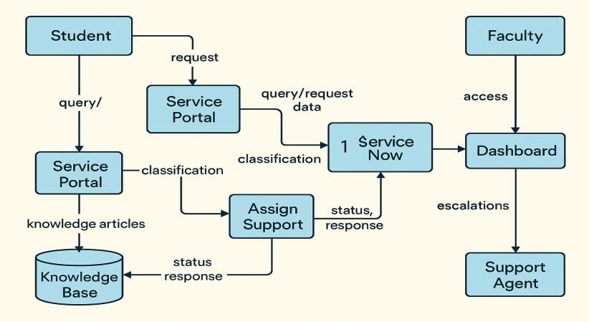

**Example:** [**(Simplified)**](https://developer.ibm.com/patterns/visualize-unstructured-text/)

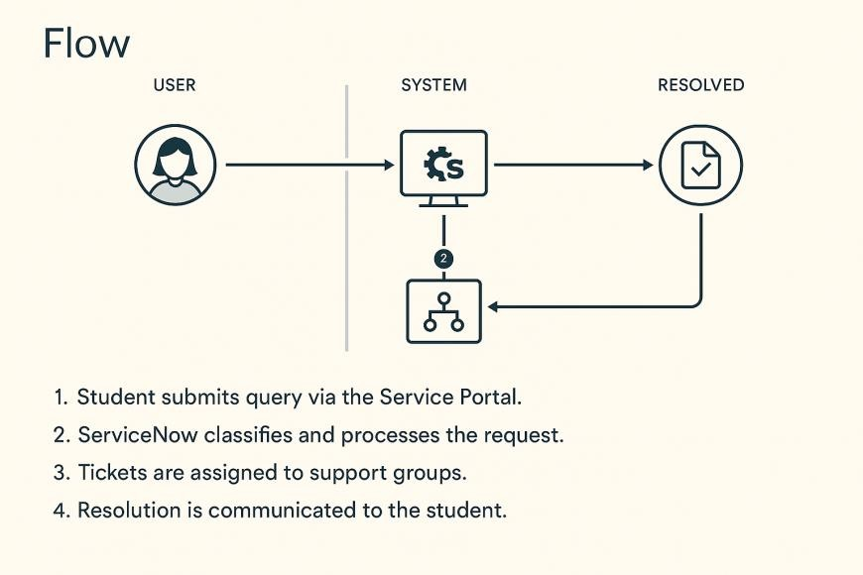

**User Stories**

Use the below template to list all the user stories for the product.

|  |  |  |  |  |  |  |
| --- | --- | --- | --- | --- | --- | --- |
| **User Type** | **Functional**  **Requirement**  **(Epic)** | **User**  **Story**  **Number** | **User Story /**  **Task** | **Acceptance**  **criteria** | **Priority** | **Release** |
| Student  (Mobile user) | Registration | USN-1 | As a user, I can register for the application by entering my email, password, and confirming my password. | I can access my account / dashboard | High | Sprint-1 |
|  |  | USN-2 | As a user, I will receive confirmation email once I have registered for the application | I can receive confirmation email & click confirm | High | Sprint-1 |
|  |  | USN-3 | As a user, I can register for the application | I can register & access the dashboard with | Low | Sprint-2 |
| **User Type** | **Functional**  **Requirement**  **(Epic)** | **User**  **Story**  **Number** | **User Story /**  **Task** | **Acceptance**  **criteria** | **Priority** | **Release** |
|  |  |  | through  Facebook | Facebook  Login |  |  |
|  |  | USN-4 | As a user, I can register for the application through Gmail |  | Medium | Sprint-1 |
|  | Login | USN-5 | As a user, I can log into the application by entering email  & password |  | High | Sprint-1 |
|  | Dashboard |  |  |  |  |  |
| Customer  (Web user) |  |  |  |  |  |  |
| Customer  Care  Executive |  |  |  |  |  |  |
| Administrator |  |  |  |  |  |  |
|  |  |  |  |  |  |  |
|  |  |  |  |  |  |  |
|  |  |  |  |  |  |  |